SUPPLY CHAIN MANAGEMENT SYSTEM

Submitted as partial fulfillment for the award of the Degree of Bachelor of Technology in

Information Technology

Department of Information Technology

CERTIFICATE

External Examiner: ____________________________________________________ (Signature with date)

Internal Examiner: _____________________________________________________
(Signature with date)

Head of the Department: ____________________________________________________
(Signature with date)

Acknowledgement

ABSTRACT

“SUPPLY CHAIN MANAGEMENT SYSTEM” is the management of a network of interconnected businesses involved in the ultimate provision of product and service packages required by end customers. It spans all movement and storage of raw materials, work-in-process inventory, and finished goods from point-of-origin to point-of-consumption. It is mainly designed for the production sector, which gives information related to client and dealers of the company with respect to product launches.

This application is designed to run on any computer. There is need to install java software on client side machine. Based on the designation of the user who registers into the application he has the permission to submit his registration form and then specify the requirements. This Document plays a vital role in companies are the targets of the Supply chain management Tool. Thus it is expected that the company will deal directly with each clients of the company regarding product information. . It fulfills different requirements of client’s. The specific purpose of the system is to automate the communication between the management (Admin), clients and the dealers of the organization.

CONTENTS

- INTRODUCTION

  - PURPOSE
  - INPUT/OUTPUT

- REQUIRMENT SPECIFICATION

  - HARDWARE REQUIRMENTS
  - SOFTWARE REQUIRMENTS
  - TECHNLOGIES USED

- ASSUMPTIONS

  - EXISTING SYSTEM
  - PROPOSED SYSTEM

4. SYSTEM DESIGN

4.1 ABOUT UML
4.2 UML DIAGRAMS

5. DATA BASE DESIGN

5.1 DATA BASE TABLES

6. IMPLEMENTATION

6.1 MODULES
6.2 SCREEN SHOTS

- CONCLUSION

7.1 FUTURE ENHANCEMENTS

8. BIBILIOGRAPHY

INTRODUCTION

1. INTRODUCTION

The “SUPPLY CHAIN MANAGEMENT SYSTEM” is the web-based system, designed for a production sector, which gives information related to the clients and dealers of the company with respect to its product launches. This product develops a system that can be used by the company management to keep track of the sales, dealers and its clients. In the existing method of tracking of all the details is tedious and time consuming. Any product survey and launching of the area carried out manually by representatives, which is a time taking task. It fulfills different requirements of clients of the company. The specific purpose of the system is to automate the communication between clients, Admin and the dealers of the organization.

PICTORIAL VIEW OF THE SYSTEM

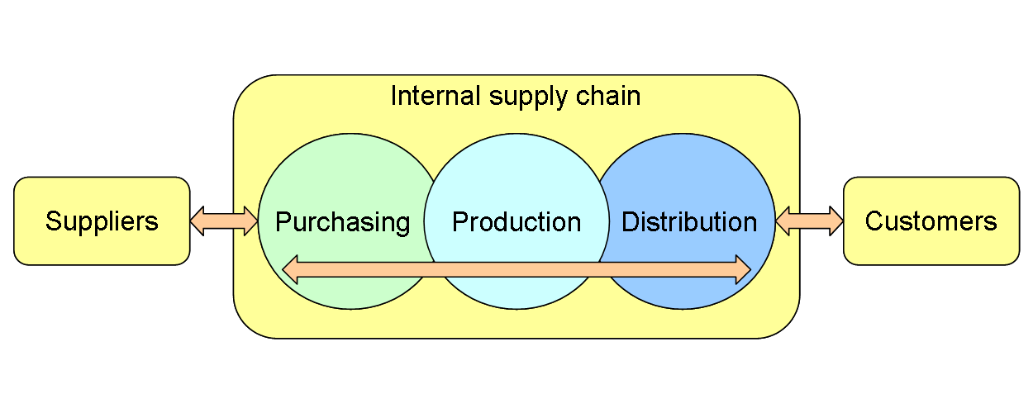

1.1 PURPOSE

The specific purpose of the system is to automate the communication between the management, clients and the dealers of the organization. This project maintains the information related to the client and dealers of the company with respect to its product launch. This will also keep track of sales and dealers. The scope of this project is to enable the user of an organization to view the issues through the LAN/Internet. Based on the category of the user i.e. employee or administrator, the various parts of the system are made available to the users.

1.2 INPUT AND OUTPUT OF THE PROJECT

“Supply chain management” is basically, the movement of raw materials into finished goods. In this project the Client provides its requirements about the product. The admin,then contacts its various dealers for gathering the requirements.The dealers displays the list of items from which the admin selects the items as specified by the client.After gathering the required items,admin gives the gathered items to the inventory department where the processing is done. The final product is manufactured and then finally delivered to the client which is the output of the project. In the mean while the manufacturing cost is tabulated by the accounting department and given to the client. Finally the client gives its feedback which is transferred to the Admin and the dealers.

REQUIREMENT SPCIFICATIONS

2. REQUIREMENT SPCIFICATIONS

2.1 HARDWARE REQUIREMENTS:

Processor Intel Pentium family

RAM 256 MB

Hard disc 16 GB

Operating System Windows 2000

2.2 SOFTWARE REQUIREMENTS:

Front End HTML

Back End M.S Access

Web server Apache Tomcat 5.1

Languages Java using JSP and JDBC

2.3 TECHNOLOGIES USED

2.3.1 INTRODUCTION TO JAVA

Java is a programming language originally developed by James Gosling at Sun Microsystems.The language derives much of its syntax from C and C++ but has a simpler object model and fewer low-level facilities. Java applications are typically compiled to bytecode that can run on any Java virtual machine (JVM) regardless of computer architecture.

One characteristic of Java is portability, which means that computer programs written in the Java language must run similarly on any supported hardware/operating-system platform. One should be able to write a program once, compile it once, and run it anywhere.

This is achieved by compiling the Java language code, not to machine code but to Java bytecode – instructions analogous to machine code but intended to be interpreted by a virtual machine (VM) written specifically for the host hardware. End-users commonly use a Java Runtime Environment (JRE) installed on their own machine for standalone Java applications, or in a Web browser for Java applets
.
Standardized libraries provide a generic way to access host specific features such as graphics, threading and networking. In some JVM versions, bytecode can be compiled to native code, either before or during program execution, resulting in faster execution.

A major benefit of using bytecode is porting. However, the overhead of interpretation means that interpreted programs almost always run more slowly than programs compiled to native executables would, and Java suffered a reputation for poor performance. This gap has been narrowed by a number of optimisation techniques introduced in the more recent JVM implementations.

One such technique, known as just-in-time (JIT) compilation, translates Java bytecode into native code the first time that code is executed, then caches it. This results in a program that starts and executes faster than pure interpreted code can, at the cost of introducing occasional compilation overhead during execution. More sophisticated VMs also use dynamic recompilation, in which the VM analyzes the behavior of the running program and selectively recompiles and optimizes parts of the program.

2.3.2 Java’s Magic: The Byte Code:

The key that allows java to solve both the security and the portability problems just described is that the output of the java compiler is not an executable code. Rather, it is Byte Code. Byte Code is a highly optimized set of instructions designed to be executed by virtual machine that the java Run-time system emulates. This may come as it of surprise as you know c++ is compiled, not interpreted-mostly because of performance concerns. However, the fact that a java program is interpreted helps solve the major problems associated with downloading the program over the Internet.
Here is why java was designed to be interpreted language. Because java programs are interpreted rather than compiled .It is easier to run them in wide variety of environments. Only the java runtime system needs to be implemented for each platform. Once the runtime package exists for a given system any java program can run on it. If java were a compiled language then different versions of the same program will have to exist for each type of CPU connected to the Internet. Thus interpretation is the easiest way to create truly portable programs.

Although java was designed to be interpreted, there is technically nothing about java that prevents on the fly compilation of Byte Code into native code. However, even if dynamic compilation were applied to Byte Code, the portability and safety would still apply, because the run time system would still be in change of the execution environment.
2.3.3 Java Virtual Machine
A Java Virtual Machine (JVM) is a set of computer software programs and data structures which use a virtual machine model for the execution of other computer programs and scripts. The model used by a JVM accepts a form of computer intermediate language commonly referred to as Java bytecode. This language conceptually represents the instruction set of a stack-oriented, capability architecture.

Java Virtual Machines operate on Java bytecode, which is normally generated from Java source code; a JVM can also be used to implement programming languages other than Java. For example, Ada source code can be compiled to Java bytecode, which may then be executed by a JVM.

The JVM is a crucial component of the Java Platform. Because JVMs are available for many hardware and software platforms, Java can be both middleware and a platform in its own right — hence the trademark write once, run anywhere. The use of the same bytecode for all platforms allows Java to be described as "compile once, run anywhere", as opposed to "write once, compile anywhere", which describes cross-platform compiled languages. The JVM also enables such unique features as Automated Exception Handling which provides 'root-cause' debugging information for every software error (exception) independent of the source code.

2.3.4 HYPER TEXT MARKUP LANGUAGE (HTML)

HTML is a language used to create hypertext documents that have hyperlinks embedded in them .You can build web pages. It is only a formatting language and not a programming language. Hyperlinks are underlined or emphasized words or locations in a screen that lead to other documents. WWW is a global, interactive, graphical, hypertext information system.
The behind hypertext is that instead of reading text in rigid liner structure you can easily jump from point to another point .You can navigate through the information based on your interest and preferences.

Platform Independentency:
If you can access Internet, you can access WWW, irrespective of your Operating System and the Operating System of Web Server you are accessing .All you require is to view and download the HTML files, which are on the WWW, are browser and Internet connections.
HTML is a language for describing structured documents. HTML describes the structure of documents -lists, heading, and paragraph, etc. Elements of web document are through the usage of HTML tags. It is tags that describe documents. Anything that is not a tab is part of a document itself

Advantages:
An HTML document is a small and hence easy to send over the net. It is small because it does not include format information.
HTML documents are cross platform compatible and device independent. You only need HTML readable browser to view them. Font names, locations etc are required.

2.3.5 JAVA SCRIPT

JAVA script enables you to embed commands in an HTML page. When a compatible web browser, such as Netscape Navigator 2 or higher or Internet explorer 3 or higher, downloads the page, your JAVA script commands are loaded by the web browser as part of the HTML document. These commands can be triggered when the user clicks page items, manipulates gadgets and fields in an HTML form, or moves through the page history list.

Scripting Language:
JavaScript enables Web authors to write small scripts that execute on the users’ browsers rather than on the server. An application that collects data from a form and then posts it to the server can validate the data for completeness and correctness, for example, before sending it to the server. This can greatly improve the performance of the browsing session because users don’t have to send data to the server until it has been verified as correct.
Another important Web browser scripting languages such as JavaScript comes as a result of the increased functionality being introduced for Web browsers in the form of Java applets, plug-ins, Dynamic HTML elements, Active X Controls, and VRML objects and worlds. Web authors can use each of these things to add extra functions and interactivity to a Web page. Scripting language acts as the glue that binds everything together.
A Web page might use an HTML form to get some user input and then set a parameter for a Java applet based on that input. It is usually a script that carries out.

Use of JavaScript:
- JavaScript provides a fairly complete set of built-in functions and commands, enabling you to perform math calculations, manipulate strings, play sounds, open new windows and new URLs, and access and verify user input to your Web forms.
- Code to perform these actions can be embedded in a page and executed when the page is loaded. We can also write functions containing code that is triggered by events you specify. You can write a JavaScript method that is called when the user clicks submit button of a form, for example, or one that is activate when the user clicks a hyperlink on the active page.
- JavaScript can also set the attributes, or properties, of Web page elements, Active-x controls, Java applets and other objects present in the browser.
- This way, you can change the behavior of plug-ins or other objects without having to rewrite them. Your JavaScript code could automatically set the text of an Active-X Label Control, for example, based on what time the page is viewed.
- JavaScript commands are embedded in your HTML documents. Embedding JavaScript in your pages requires only one new HTML element: <SCRIPT> and </SCRIPT>. The <SCRIPT> element takes the attribute LANGUAGE, which specifies the scripting language to use when evaluating the script, and SRC, which can be used to load a script from an external source.

2.3.6 JDBC-ODBC

Java Data Base Connectivity (JDBC)

JDBC is a set of specification that defines how a program written in java can communicate and interact with a database. It provides a vehicle for the exchange of SQL between java application and databases. Programs developed with java and the JDBC are platform independent and vendor independent.
The same java database program can run on PC, a workstation, or java powered terminal. You can move your data from one database to another, for example from Microsoft SQL Server to Oracle and the same program can still read your data. This is in sharp contrast to the database programming typically done on personal computers today. It is all common that one writes the database application in proprietary database language, using a database management system that is available only from one or two platforms.
At the heart of the JDBC is the JDBC driver. JDBC driver is responsible for ensuring that any requests made by the application are presented to the database in away that is meaningful to the databases. JDBC was designed to support the most common form of SQL known as ANSI SQL92 entry level standard.
The JDBC consists of two layers .The top layer is the JDBC API. This API communicates with JDBC manager driver API sending, it the various SQL statements. The manager should communicate with the various third party drivers that actually connect to the database and return the information from the query or performed the action specified by the query.
Open Database Connectivity(ODBC)
Open Database Connectivity (ODBC) provides a standard software API method for using database management systems(DBMS). The designers of ODBC aimed to make it independent of programming languages, database systems, and operating systems.

JDBC-ODBC Bridge:
ODBC driver is the only driver that can be used with the multiple databases and is vendor independent. The ODBC interface remains constant no matter which database is used. This means that this type of JDBC driver only needs to speak only one language ODBC.

2.3.7 JSP (JAVA SERVER PAGES)

Java Server Pages (JSP) technology allows you to easily create Web content that has both static and dynamic components. JSP technology projects all the dynamic capabilities of Java Servlet technology but provides a more natural approach to creating static content. The main features of JSP technology are
- A language for developing JSP pages, which are text-based documents that describe how to process a request and construct a response
- Constructs for accessing server-side objects
- Mechanisms for defining extensions to the JSP language

TAGS USED IN JSP
- Declaration Tag
- Expression tag
- Script let Tag
- Directive Tag
- Action Tag

LIFE CYCLE OF JSP PAGE

A JSP page services requests as a servlet. Thus, the life cycle and many of the capabilities of JSP pages (in particular the dynamic aspects) are determined by Java Servlet technology.
When a request is mapped to a JSP page, it is handled by a special servlet that first checks whether the JSP page's servlet is older than the JSP page. If it is, it translates the JSP page into a servlet class and compiles the class. During development, one of the advantages of JSP pages over Servlets is that the build process is performed automatically.

TRANSLATION AND COMPILATION
During the translation phase, each type of data in a JSP page is treated differently. Template data is transformed into code that will emit the data into the stream that returns data to the client. JSP elements are treated as follows:
- Directives are used to control how the Web container translates and executes the JSP page.
- Scripting elements are inserted into the JSP page's servlet class. See JSP Scripting Elements for details.
- Elements of the form <jsp: XXX ... /> are converted into method calls to JavaBeans components or invocations of the Java Servlet API.

For a JSP page named page Name, the source for a JSP page's servlet is kept in the file
J2EE_HOME/repository/host/web/
Context_root/_0002fpageName_jsp.java

Both the translation and compilation phases can yield errors that are only observed when the page is requested for the first time. If an error occurs while the page is being translated (for example, if the translator encounters a malformed JSP element), the server will return a Parse Exception, and the servlet class source file will be empty or incomplete. The last incomplete line will give a pointer to the incorrect JSP element.
If an error occurs while the JSP page is being compiled (for example, there is a syntax error in a script let), the server will return a Jasper Exception and a message that includes the name of the JSP page's servlet and the line where the error occurred.
Once the page has been translated and compiled, the JSP page's servlet for the most part follows the servlet life cycle.

- If an instance of the JSP page's servlet does not exist, the container:
  - Loads the JSP page's servlet class
  - Instantiates an instance of the servlet class
  - Initializes the servlet instance by calling the JSPs Init method
- Invokes the JSPs Service method, passing a request and response object.
If the container needs to remove the JSP page's servlet, it calls the JSPs Destroy method.

EXECUTION
One can control various JSP page execution parameters using by page directives. Various errors can be encountered while executing a JSP page. So, page directives are used.
BUFFERING
When a JSP page is executed, output written to the response object is automatically buffered. You can set the size of the buffer with the following page directive:
<%@ page buffer="none|xxxkb" %>

A larger buffer allows more content to be written before anything is actually sent back to the client, thus providing the JSP page with more time to set appropriate status codes and headers or to forward to another Web resource. A smaller buffer decreases server memory load and allows the client to start receiving data more quickly.
ERROR HANDLING
Any number of exceptions can arise when a JSP page is executed. To specify that the Web container should forward control to an error page if an exception occurs, include the following page directive at the beginning of your JSP page:
<%@ page errorPage="file_name" %>

The Duke's Bookstore application page initdestroy.jsp contains the directive
<%@ page errorPage="errorpage.jsp"%>

The beginning of errorpage.jsp indicates that it is serving as an error page with the following page directive:
<%@ page isErrorPage="true|false" %>

This directive makes the exception object (of type javax.servlet.jsp.JspException) available to the error page, so that you can retrieve, interpret, and possibly display information about the cause of the exception in the error page.
JSP Versus ASP
JSP and ASP do have some basic concepts in common. They both make use of simple sever-side scripting to provide access to Web server information and functionality. They both do so using object oriented scripting. And they both started out with similar styles of delimiting this scripting from a page's content.
Yet while ASP primarily supports two scripting languages – J Script and VBScript -- JSP actually supports real Java code, not a new scripting language. The difference is that the Java code inside a JSP page is more script-like because it doesn't require Java class and package definitions. The Java code inside JSP is added to methods of a Java Servlet that are generated the first time the JSP is requested.
JSP versus SERVLET
Servlets and Java Server Pages are complementary APIs, both providing a means for generating dynamic Web content. A servlet is a Java class implementing the javax.servlet.Servlet interface that runs within a Web or application server's servlet engine, servicing client requests forwarded to it through the server. A Java Server Page is a slightly more complicated beast. JSP pages contain a mixture of HTML, Java scripts (not to be confused with JavaScript), JSP elements, and JSP directives. The elements in a Java Server Page will generally be compiled by the JSP engine into a servlet, but the JSP specification only requires that the JSP page execution entity follow the Servlet Protocol.
The advantage of Java Server Pages is that they are document-centric. Servlets, on the other hand, look and act like programs. A Java Server Page can contain Java program fragments that instantiate and execute Java classes, but these occur inside an HTML template file and are primarily used to generate dynamic content. Some of the JSP functionality can be achieved on the client, using JavaScript. The power of JSP is that it is server-based and provides a framework for Web application development. Rather than choosing between servlets and Java Server Pages, you will find that most non-trivial applications will want to use a combination of JSP and servlets.

ADVANTAGES OF JSP:
- Set your classpath (NOT required).
- Compile your code (NOT required).
- Use packages to avoid name conflict (NOT required).
- Put JSP in special directory (NOT required)
  - Servlets are kept in (webapps/examples/WEB-INF/classes)
  - JSPs are kept in (webapps/examples)
- Use special URLs to invoke JSP page. (NOT required)
  - Accessing LoginServlet (http://localhost:8080/examples/servlet/LoginServlet)
  - Accessing Login.jsp (http://localhost:8080/examples/Login.jsp)

ASSUMPTIONS

3. ASSUMPTIONS

3.1 EXISTING SYSTEM

Supply chain management (SCM) is the management of a network of interconnected businesses involved in the ultimate provision of product and service packages required by end customers Supply Chain Management spans all movement and storage of raw materials, work-in-process inventory, and finished goods from point-of-origin to point-of-consumption. Organizations increasingly find that they must rely on effective supply chains, or networks, to successfully compete in the global market and networked economy. During the past decades, globalization, outsourcing and information technology have enabled many organizations to successfully operate solid collaborative supply networks in which each specialized business partner focuses on only a few key strategic activities. Any product survey and launching of the area carried out manually by representatives, which is a time taking task. And even gathering all the requirements from different dealers was also very tedious.

3.2 PROPOSED SYSTEM

The product designed is the web-based system, mainly for production sector, which gives information related to the clients and dealers of the company with respect to its product launches. This product develops a system that can be used by the company management to keep track of the sales, dealers and its clients. It spans all movement and storage of raw materials, work-in-process inventory, and finished goods from point-of-origin to point-of-consumption.

This application is designed to run on any computer. There is need to install java software on client side machine. Based on the designation of the user who registers into the application he has the permission to submit his registration form and then specify the requirements. This Document plays a vital role in companies are the targets of the Supply chain management Tool. Thus it is expected that the company will deal directly with each clients of the company regarding product information. . It fulfills different requirements of client’s. The specific purpose of the system is to automate the communication between the management (Admin), clients and the dealers of the organization.

SYSTEM DESIGN

  - SYSTEM DESIGN

4.1 ABOUT UML

Unified Modeling Language ("UML") is the industry standard "language" for describing, visualizing, and documenting object-oriented (OO) systems. UML is a collection of a variety of diagrams for differing purposes. Each type of diagram models a particular aspect of OO design in an easy to understand, visual manner. The UML standard specifies exactly how the diagrams are to be drawn and what each component in the diagram means. UML is not dependent on any particular programming language, instead it focuses one the fundamental concepts and ideas that model a system. Using UML enables anyone familiar with its specifications to instantly read and understand diagrams drawn by other people. There are UML diagram for modeling static class relationships, dynamic temporal interactions between objects, the usages of objects, the particulars of an implementation, and the state transitions of systems.

In general, a UML diagram consists of the following features:
- Entities: These may be classes, objects, users or systems behaviors.
- Relationship Lines: that models the relationships between entities in the system.
  - Generalization: a solid line with an arrow that points to a higher abstraction of the present item.
  - Association: a solid line that represents that one entity uses another entity as part of its behavior.
  - Dependency: a dotted line with an arrowhead that shows one entity depends on the behavior of another entity.

TYPES OF UML DIAGRAMS:

UML defines nine types of diagrams: class (package), object, use case, sequence, collaboration, statechart, activity, component, and deployment.

1.CLASS DIAGRAM:
Class diagrams are the backbone of almost every object oriented method, including UML. They describe the static structure of a system.

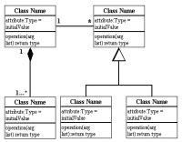
2.USE CASE DIAGRAM:

Use case diagrams model the functionality of system using actors and use cases.

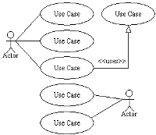
3.SEQUENCE DIAGRAM:
Sequence diagrams describe interactions among classes in terms of an exchange of messages over time.
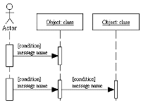

4. COLLABORATION DIAGRAM:
Collaboration diagrams represent interactions between objects as a series of sequenced messages. Collaboration diagrams describe both the static structure and the dynamic behavior of a system.
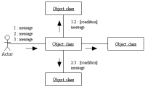

5.ACTIVITY DIAGRAM:

Activity diagrams illustrate the dynamic nature of a system by modeling the flow of control from activity to activity. An activity represents an operation on some class in the system that results in a change in the state of the system. Typically, activity diagrams are used to model workflow or business processes and internal operation.
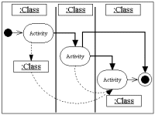

4.2 UML DIAGRAMS

4.2.1 Class Diagram

Client Transaction

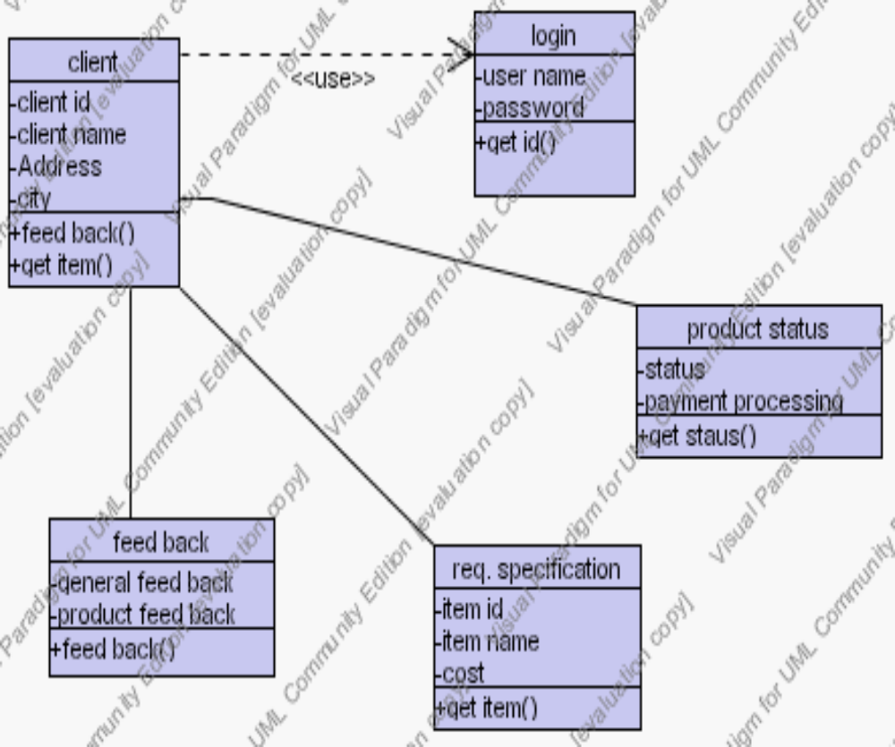

The above diagram shows the client functionality,where the client logs in with the user name and password,specifies the requirements,verifies the product status and finally gives the feedback.This is shown with the help of Classes and relationship between these classes.

Admin functions

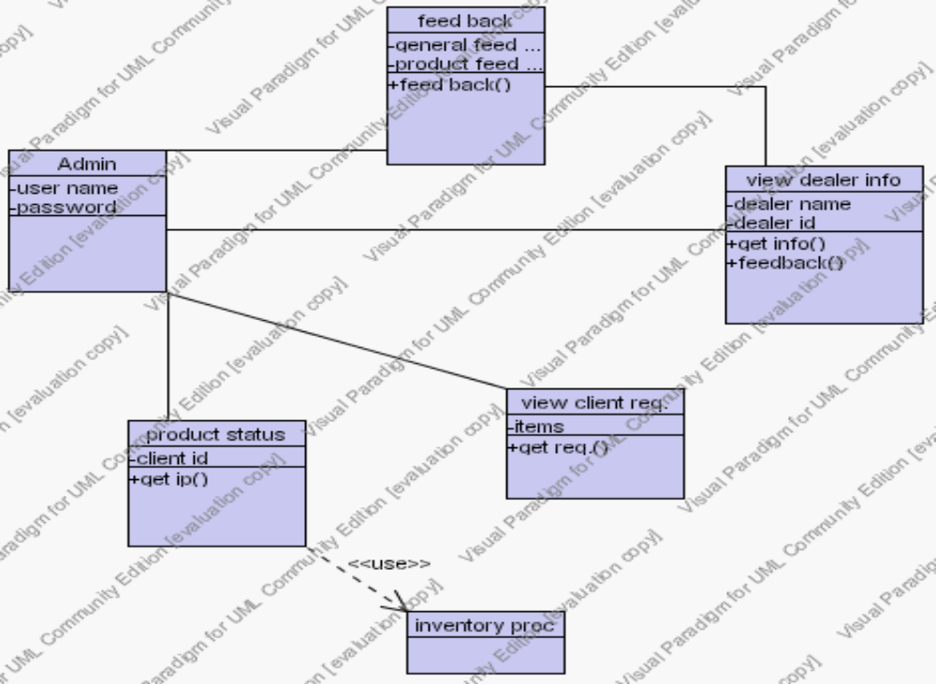

The above figure shows the Admin functions.There are six classes which are associated with each other.The ‘Admin’ class is the main classs which is associated with the ‘View client req’,’View dealer info’,’Product status’,’Inventory proc’and ‘Feed back’ classes.

Dealer Functions

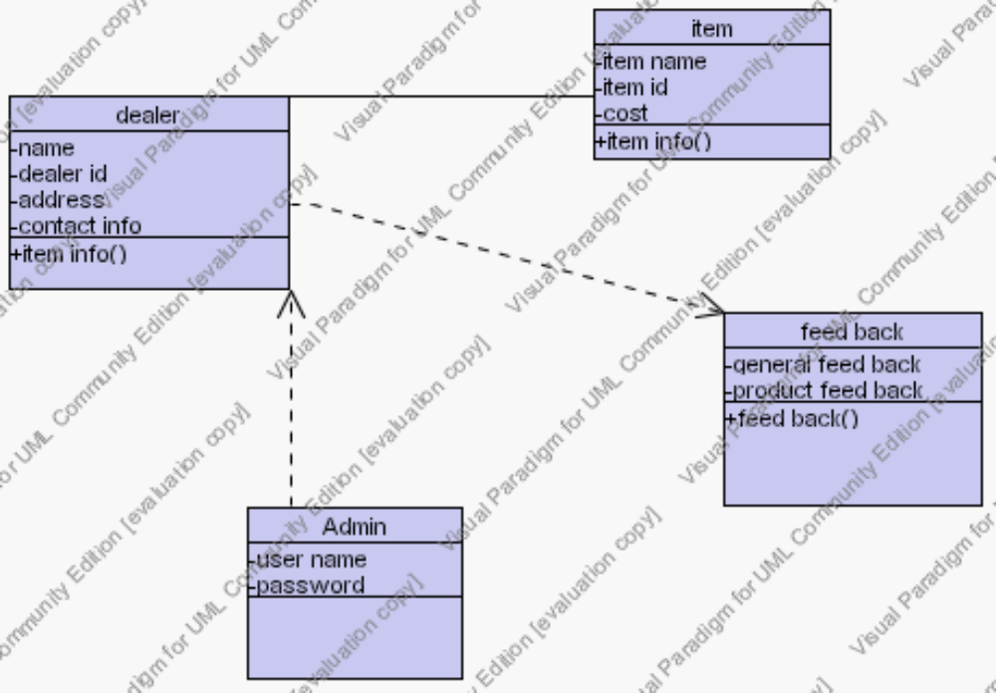

The above class diagram shows the Dealer functionality.The dealer class is associated with the ‘Item’ class and it is dependent on the ‘Admin’ class and the ‘Feed back’ class to get the feed back specified by the client.

4.2.2 Use Case Diagram

Work flow of Admin

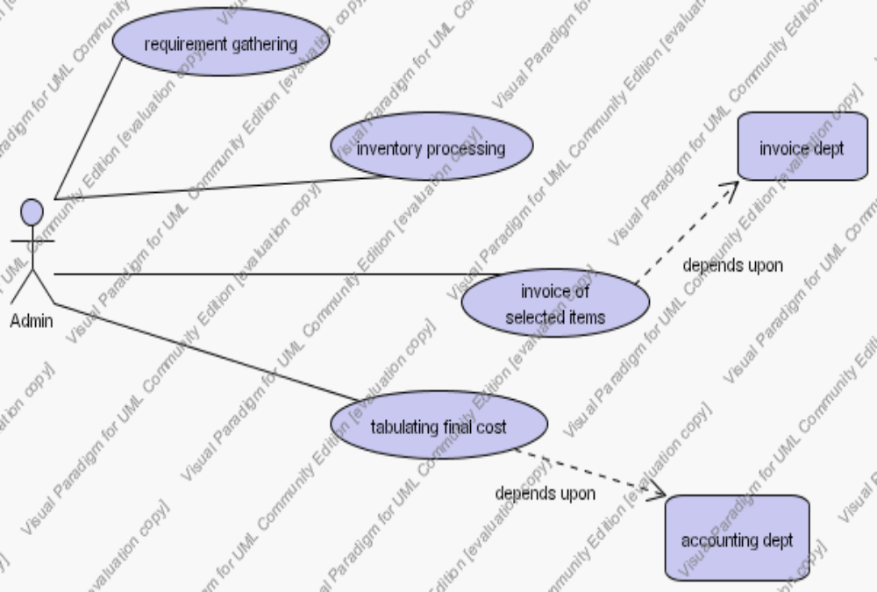

The use case diagram model the functionality of the system. The above figure shows the functionality of the Admin.The functions are represented in the form of use cases like the requirement gathering, inventory processing, invoice of the selected items and finally the cost tabulation.

Client-Admin Transactions

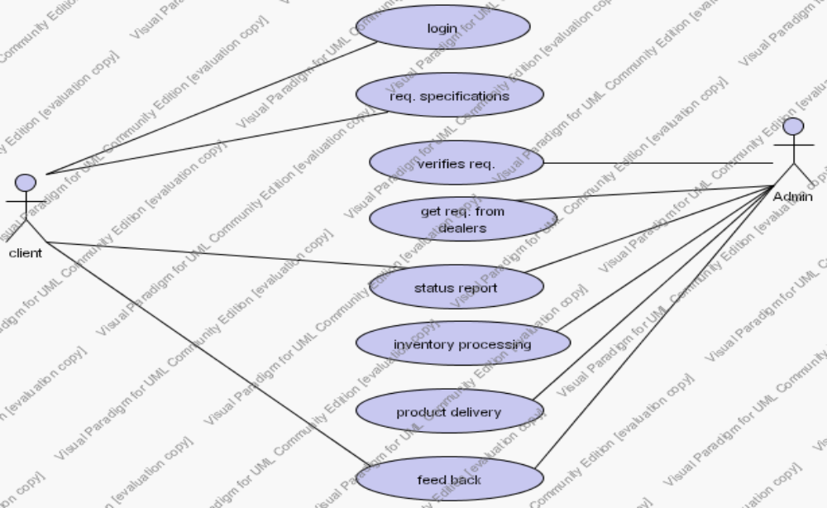

The above figure depicts the Client-Admin transactions, where Client and Admin are the two actors and their functions are shown by the use cases.

Admin-Dealer Transactions

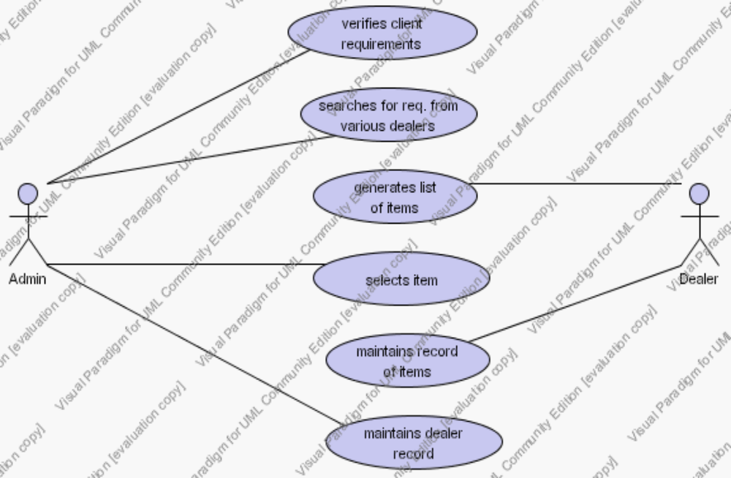

The above diagram is for the Admin-Dealer transactions, where Admin and dealer are the two actors and their functions are shown by the use cases, like the Dealer generates the item’s list and maintains the record of the items; similarly the Admin verifies the client’s requirements, searches the items, selects the item and maintains the Dealer record.

4.2.3 Sequence Diagram

Client-Admin Sequence diagram

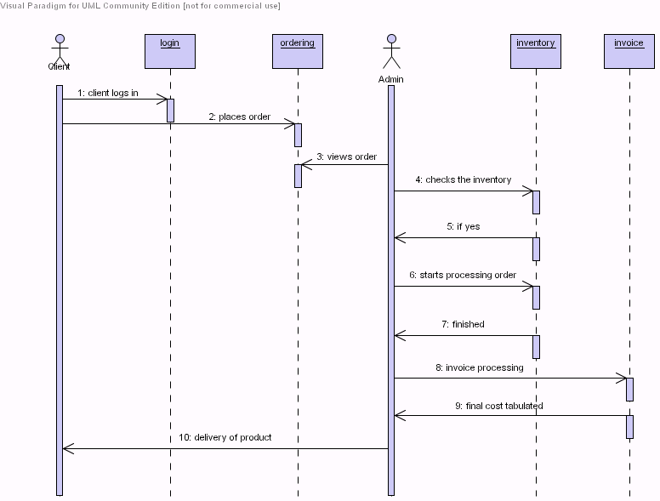

The Sequence Diagram shows the interaction among the classes in terms of messages over a period time. The above figure shows the Client-Admin transactions, where Client and Admin are the two actors and login, ordering, inventory and invoice are the classes. The communication is done with messages.

Admin-Dealer Sequence

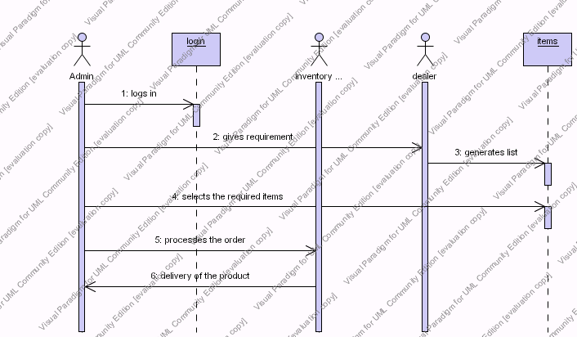

This figure shows the Admin-Dealer transactions, where Admin, Dealer and Inventory manager are the actors. Login and Items are the two classes. Messages are passed between these.

Feed back sequence

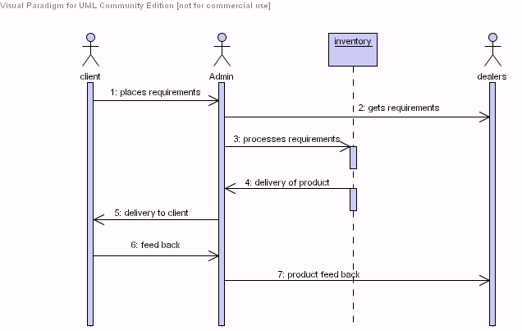

The above diagram is for the Feed back which is given by the Client after the product has been delivered to the Client. The Feed back is given to the Admin which is further passed to the Dealer if it is regarding the product functionality. Where as the general Feed back is kept with the Admin.

4.2.4 Collaboration Diagram

Work Flow Collaboration

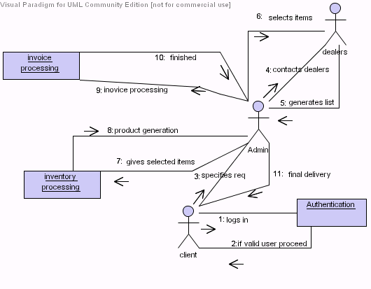
Collaboration diagrams represent interactions between objects as a series of sequenced messages. Collaboration diagrams describe both the static structure and the dynamic behavior of a system.In the above figure Client, Admin, Dealer are the actors where as ‘invoice processing’, ‘inventory processing’and ‘Authentication’ are the objects.

4.2.5 Activity Diagram

Work Flow Activity

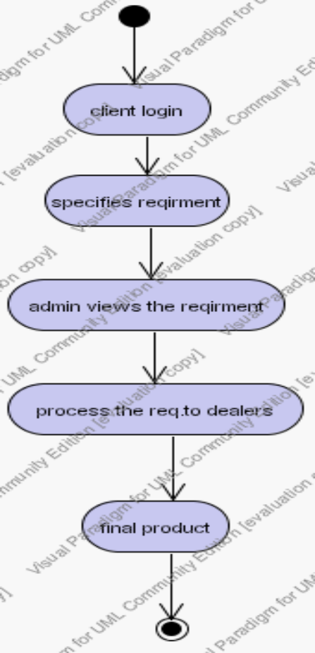

Activity diagrams are used to model workflow or business processes and internal operation.The above figure shows the work flow the system. The client logs in, gives the requirements,Admin views the requirements,contacts the Dealers and then finally generates the final product.

DATA BASE DESIGN

5.DATA BASE DESIGN
5.1 Data Base Tables
5.1.1 Monitor Dealers
ItemCode | ItemName | Model | Specification | WarrantyPeriod | Cost
001A | Monitor-LG | 15inch-TFT | Black | 2years | Rs 4500
002A | Monitor-IBM | 14inch-CRT | White | 3years | Rs 5000
003A | Monitor-DELL | 17inch-TFT | White | 4years | Rs 6000
004A | Monitor-HP | 12inch-TFT | Black | 2years | Rs 7000
005A | Monitor-Lenova | 17inch-CRT | Black | 3years | Rs 5500

Table Name: Monitor Dealers
Field Name Description
1. ItemCode Gives the code for particular item.
2.Item Name Gives the name of the item
3.Model Gives the clear view about the model
4.Specifications Gives the extra features about item
5.Waranty Period Gives the Waranty Period
6.Cost Specifies the Cost of the Item

5.1.2 Mouse Dealers
ItemCode | ItemName | Model | Specification | WarrantyPeriod | Cost
006B | Zenith | 12.5*3.5*4.2cm | WiredOptical | 2years | Rs2500
007B | Zebronic | 10.2*2.2*5.8cm | WirelessOptical | 3years | Rs2000
008B | Samsung | 13.5*4.7*6.2cm | WirelessOptical | 2years | Rs3000
009B | Logitech | 10.8*3.5*2.5cm | Wireled | 1years | Rs3500
0010B | Hcl | 13.4*4.3*3.4cm | WirelessOptical | 3years | Rs2000

5.1.3 Key Board Dealers

ItemCode | ItemName | Model | Specification | WarrantyPeriod | Cost
0011C | Samsung | Key101 | White | 2years | Rs1000
0012C | HCL | key104 | Black | 6months | Rs1500
0013C | Lenova | key114 | Grey | 1year | Rs1300
0014C | Samsung | key104 | Black | 1year | Rs1100
0015C | LG | key121 | Black | 3years | Rs1600

5.1.4 Hard Disk Dealers

ItemCode | ItemName | Model | Specification | WarrantyPeriod | Cost
0017D | HCL | 400GB | Tr=2Gbits/sec | 2years | Rs8000
0018D | IBM | 300GB | Tr=1.6Gbits/sec | 2years | Rss9000
0019D | Intel | 250GB | Tr=1.4Gbits/sec | 1.5years | Rs8000
0020D | Samsung | 200GB | Tr=1Gbits/sec | 3years | Rs7000
0021D | IBM | 100GB | Tr=1Gbits/sec | 2years | Rs8000

5.1.5 Mother Board Dealers

ItemCode | ItemName | Model | Specification | WarrantyPeriod | Cost
0023E | Intel | 7min 5sec | 2.9GB/sec | 2years | Rs19000
0024E | Nvidia | 30min | 1.8GB/sec | 2years | Rs18000
0025E | Nvidia | 15min | 1.5GB/sec | 1year | Rs16000
0026E | Intelchipset7n | 5min 3sec | 3.5GB/sec | 6months | Rs 7500
0027E | Intel Turbo | 25min | 1.2GB/sed | 8months | Rs7500

5.1.6 RAM Dealers

ItemCode | ItemName | Model | Specification | WarrantyPeriod | Cost
0028F | Infineon | DDR1 | 200GB | NA | Rs800
0029F | Hyundai | DDR2 | 250GB | NA | Rs 400
0030F | Samsung | DDR1 | 150GB | NA | Rs1500
0031F | Hynix | DDR1 | 250GB | NA | Rs700
0032F | Elpida | DDR1 | 200GB | NA | Rs600

5.1.7 Processor Dealers

ItemCode | ItemName | Model | Specification | WarrantyPeriod | Cost
0033G | IntelP4 | 900MH | 3.6 Watt | 2years | Rs10000
0034G | IntelDualcore | 2GH | 15-25 Watt | 2years | Rs12000
0035G | Intelcore2Duo | 1.0GH | 30 Watt | 3years | Rs15000
0036G | Intelpentium3 | 800MH | 4.5 Watt | 2years | Rs13000
0037G | Intel | 600MH | 6 Watt | 1years | Rs12000

5.1.8 Client Registration Table

Client ID | Text
First Name | Text
Middle Name | Text
Last Name | Text
Street | Text
City | Text
Pin code | Text
State | Text
Contact Number | Number
Mail-Id | Text
Altername mail-id | Text
Username | Text
Password | Text
Confirm Password | Text
Security Question | Text
Answer | Text
Date | Date

5.1.9 Feed Back Tables

General Feed Back

Date | Date
Client Name | Text
Comments | Text

Product Feed Back

Date | Date
Client Name | Text
Product Name | Text
Comments | Text

The Feed Back tables consist of mainly three attributes-date,client name and comments.
The product feed Back table consists of one additional attribute in conjunction with other attributes,that is the product name.

IMPLEMENTATION

6.IMPLEMENTATION

6.1 MODULES

The “Supply Chain Management System” consists of three main modules.
They are

- Admin Module
- Client Module
- Dealer Module

Admin module

In this module Administrator can checks the availability of the product, the new launched product information. It also checks the delivery of product to the clients request and filters the products which are not being ordered by the clients.
When ever the Admin log’s in into the system, it first checks the client requirements and then contacts the various dealers depending upon the requirements specified by the client.

It also keeps the record of various Dealers related to the system. Admin also gets the feed back given by the client after the delivery of the product. The Admin transfers the feed back related to the product to particular dealer. It also checks the delivery of product to the clients request and filters the products which are not being ordered by the clients.

Client Module

It consists of registration and regulations for the client. It also consists of the information about the product. The main function of the Client is that-it first gets registered into the system if it is not registered. The Client then Specifies the requirements in order to get the product build. The is intimated when the product is completely built according to the specified requirements and is ready for the delivery. The Client then gives the feed back with respect to the services provided and the functionality of the product.

Dealer Module

The Dealer module consists of the entire information about the dealers.
It consists of the list of Dealer associated with the system. The dealers maintain the record of items and generate the list of items when needed. The dealer also updates the list of items. The dealer gets the feed back related to the product functionality and the quality from the Admin.

The above are the three main modules of the project. The sub module of the project is the Feed back module.

Feed Back Module

This module is generally used to specify the feed back after the product delivery. It is mainly used by the client to give the feed back. This module consists of two main parts Product Feed back and the General Feed back .The product feed back is transferred to the particular dealer which will be regarding the product functionality and the quality. The next one, that is, the general feed back is kept with the Admin which will be regarding the services provided.

6.2 SCREEN SHOTS

6.2.1 Home Page

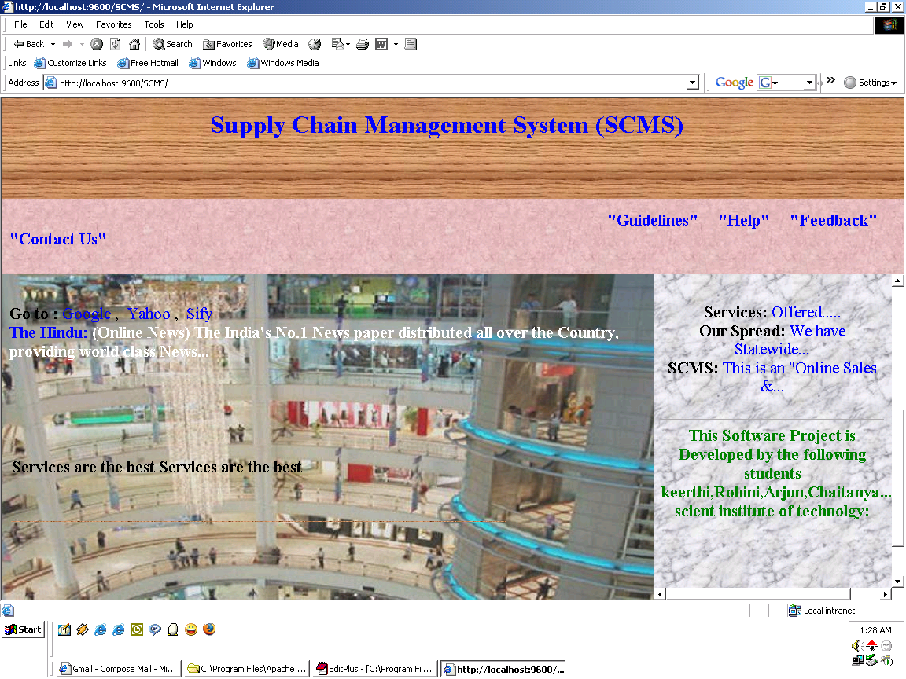

This is the home page of the “Supply Chain Management System”.

6.2.2 Products Offered

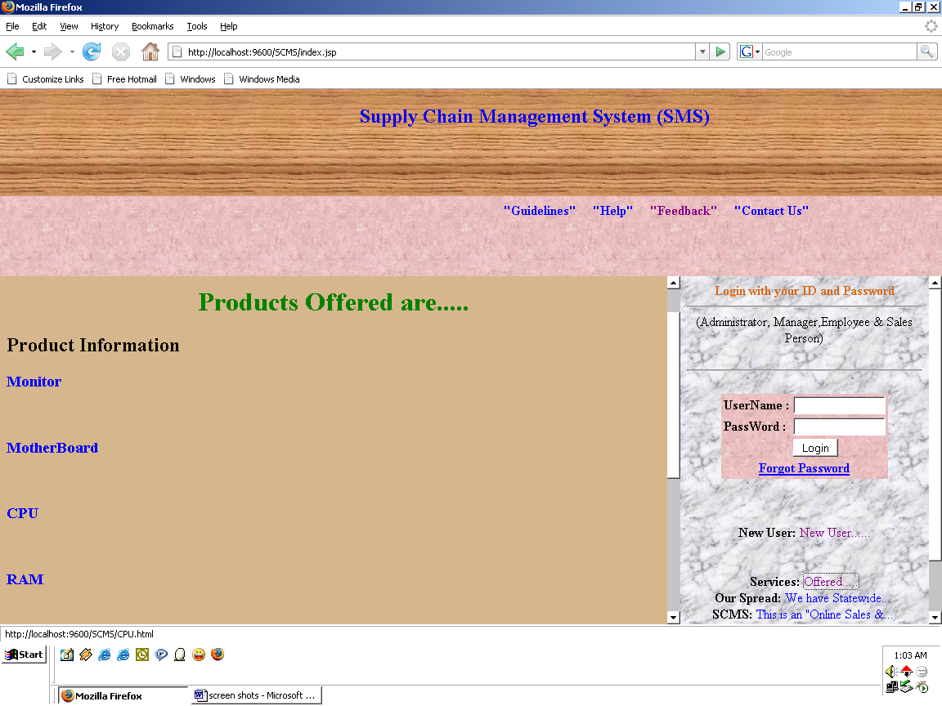

This screen is for the Products offered by us.links are provided on each and every product.when ever the client clicks the particular product,the details of the product appears.

6.2.3 Client Registration Form

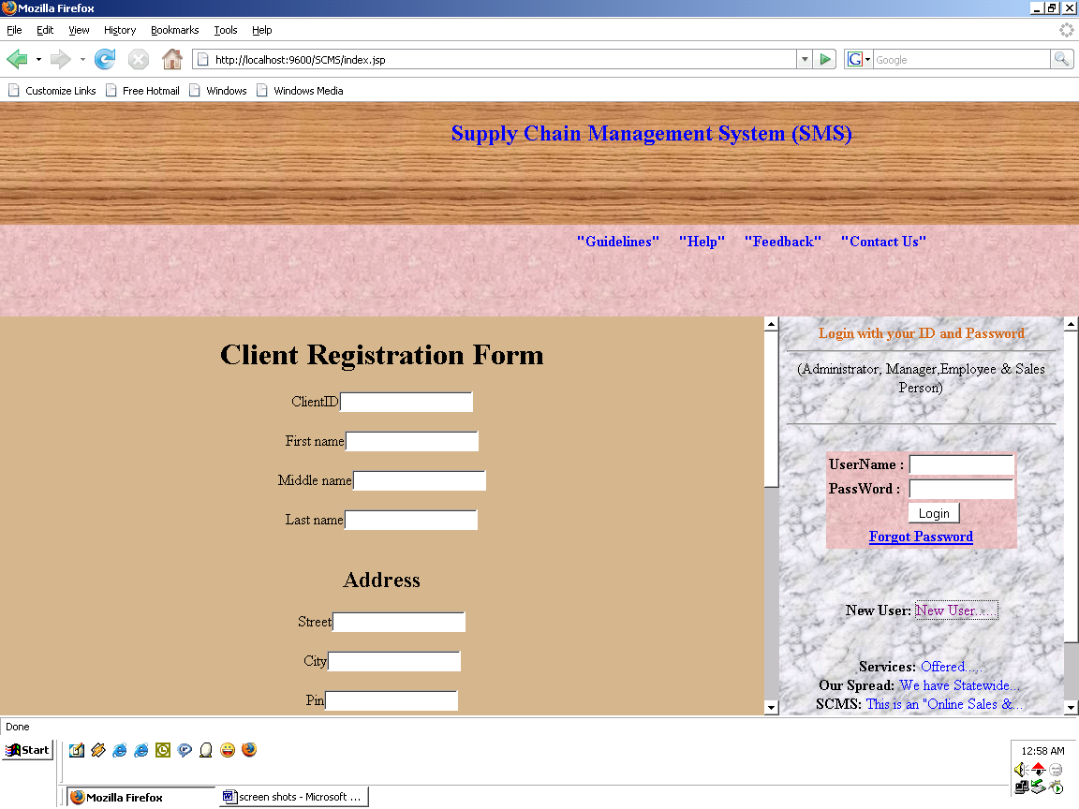

If the user is new, then he has to first get registered. The above screen is the Client registration form which has to be completely filled by the Client. Only after the registration the client is considered as the authorized and he can log in into the system.

6.2.4 Client Logging In

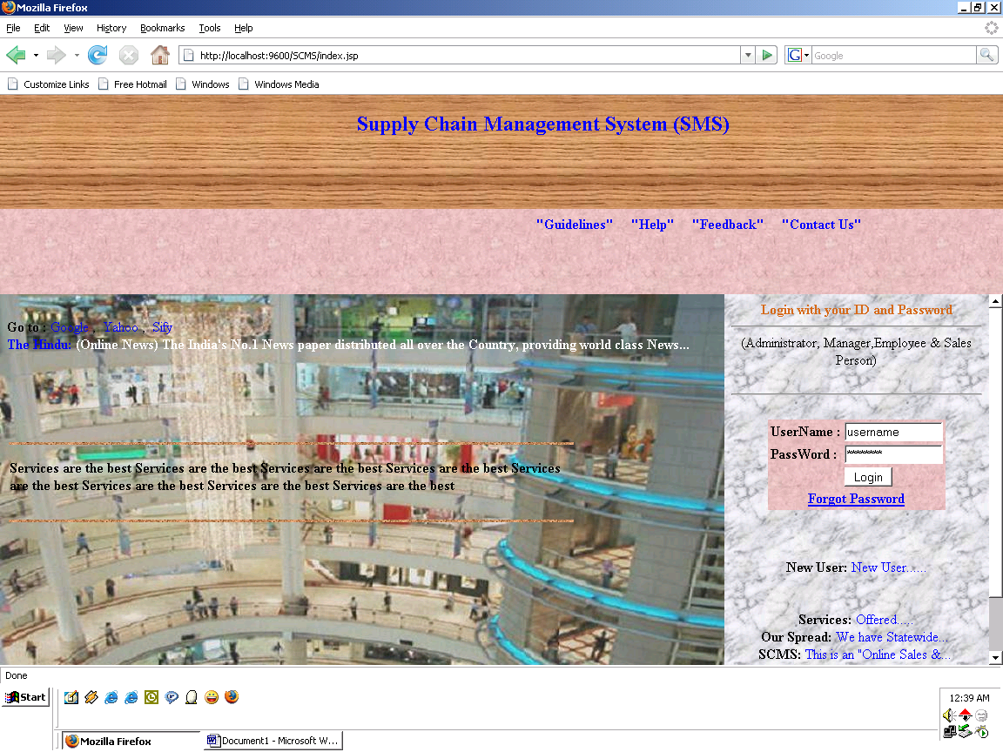

After the client gets registered, he logs in into the system with the valid user name and password. The above screen illustrates the same.

6.2.5 Client Home Page

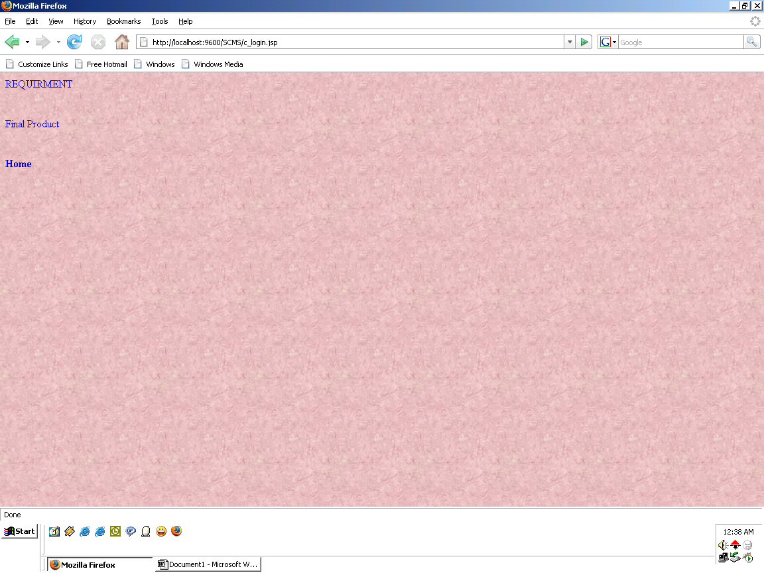

After the Client logs in , the above screen appears.The client home page consists of the requirement specification,final product and the log out.

    - Requirements form

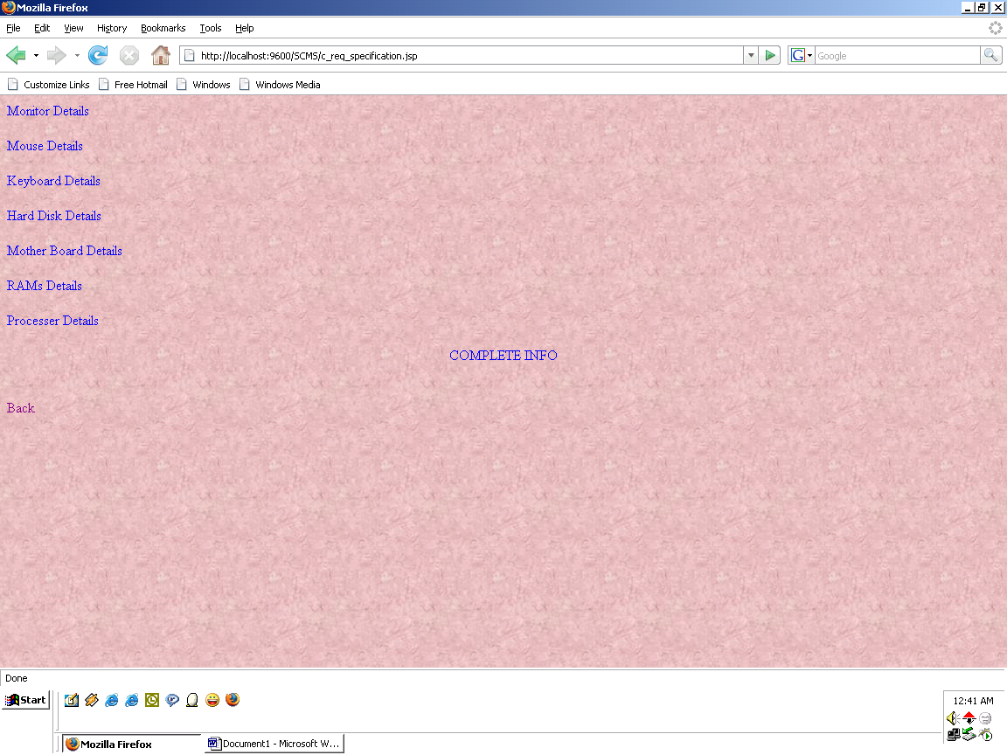

The above screen shows the list of the products. Whenever the client clicks the particular product, the more detail specification about the product and the varieties in the product appears.

    - Monitor Details

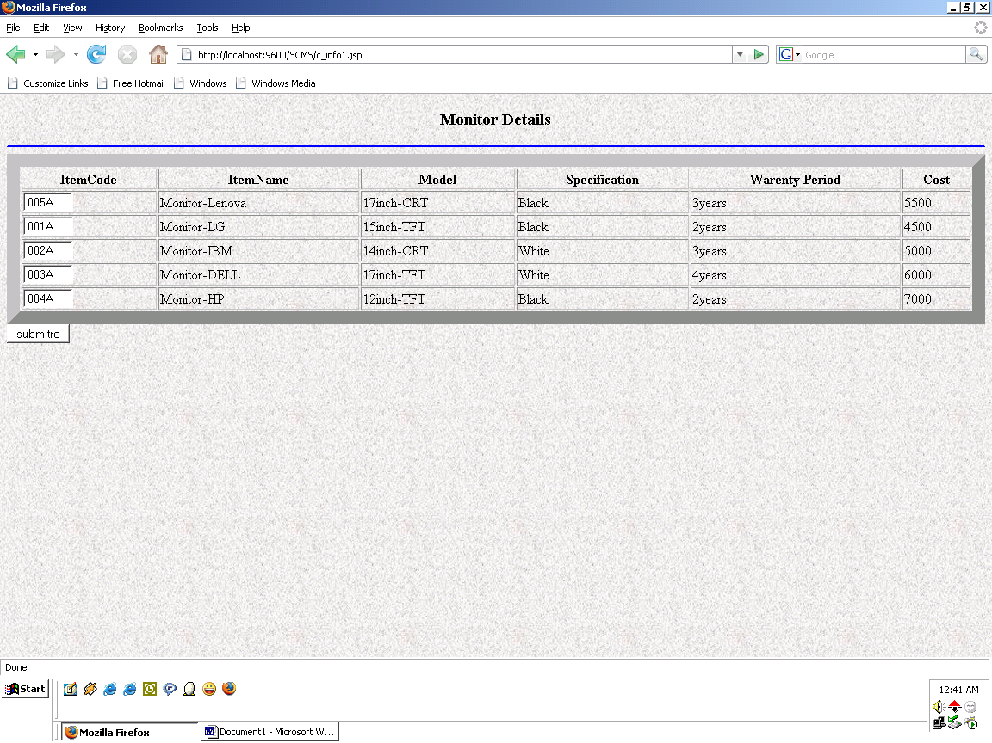

When the client clicks on the monitor details, the above screen appears and the client selects the item from the available list of items.

    - Displaying the Selected Items

The above screen appears after the selection of the items. This screen appears after each selection including the previous selections made by the client.

    - Admin Log in

The above screen shows the Admin logging in with the user name and password.

    - Admin Home page

When the client logs in with the user name and password the above home page appear.

\

    - Client’s Requirements

When the Admin clicks on the requirements the above screen appears form which the Admin selects the client id and views the requirements.

6.2.12 Requirements Screen

After selecting the client id,the particular clients requirements are displayed.the above screen represents the same.

6.2.13Dealer Information

When the Admin Clicks on the Dealer info the above scree appears.again on clicking on the view dealer the list of the dealers appear.

6.2.14Viewing Dealers

After viewing the client’s requirements, the Admin contacts various dealers. The above screen shows the list of dealers.

6.2.15 getting the requirements from the dealers

Selecting the monitors as required by the client. The above screen represents the selection.

6.2.16 getting the requirements

Selecting the Mother Board from that particular Dealer.The above screen represents the same.

6.2.17 getting the requirements

Selecting the Processor from the particular dealer. The above screen represents the same. Like wise all the requirements are gathered from various dealers.

6.2.18 cost Tabulation

According to the requirents given by the client,the product is built and the cost is tabulated at the Admin side which is then sent to the client.

6.2.19 Product Delivery to Client

The final cost generated is sent to the client as the part of the delivery. The above screen shows the client viewing the final cost of the product.

6.2.20 Feed Back

After the product delivery the Client gives the feed back which is represented in the above screen.

6.2.21 General Feed back

The Client enters the date,name and the comments about the services provided.

6.2.22 Product Feed Back

The above screen gives the product feed back.The client specifies the name,product name and the comments.This feed back is given to the dealer of the particular product.

6.2.23 Viewing the Feed Back

After Client gives the Feed Back,the Admin views it.The Above screen represents the same.

CONCLUSION

7. CONCLUSION

- This project has more scope in future and it can be integrated further

- This project is successfully implemented with all the features mentioned earlier.

- This project is designed keeping in view the needs of the commen user and satisfying the user upto the maximum extent possible.

- Deployement of our application will help the user to reduce the unneceaasry wastage of time in going and ordering the product manuallly.

- Therefore we are successfully able to reach the goals and target of the project.

7.1 FURTHER ENHANCEMENTS

- Delivery date and time have not been specified in our project which can be included as a further enhancement to the project.

- Dealers can also have the authentications in the futher expansion.

- The entire functions are controlled by the Admin.only one report is generated at a time.generation of more reports,keeping the day-wise schedule can also be dine as part of future enhancement to this project.

BIBILIOGRAPHY

WEB REFERENCES

- www.java.sun.com/products/jsp

- www.java.com/getjava

- en.wikipedia.org/wiki/HTML

- java.sun.com/docs/books/tutorial/jdbc

- www.webopedia.com/TERM/O/ODBC

